Use Case-2

Technical Stack:

1. Custom VPC
2. 2 public subnets for web server tier
3. 2 private subnets for data base tier and in one subnet MySQL RDS installed
4. Routing tables
5. Two EC2 instances being used
6. Implemented remote state by using AWS S3
7. Security groups for webservers and RDS instance

Below is the technical architecture of the requirement.

After Iac code implementation and if we apply below commands. We observe that require infra have been created in the AWS cloud.

terraform init

terraform plan

terraform apply

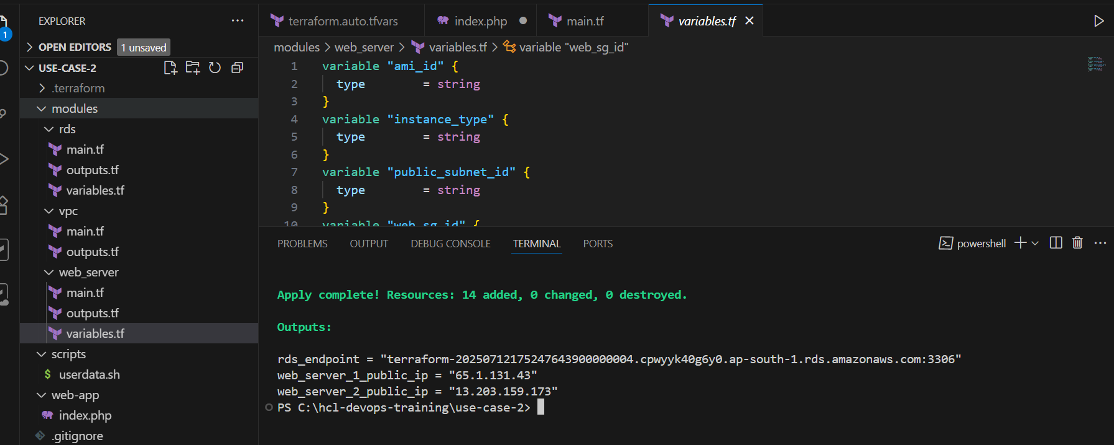

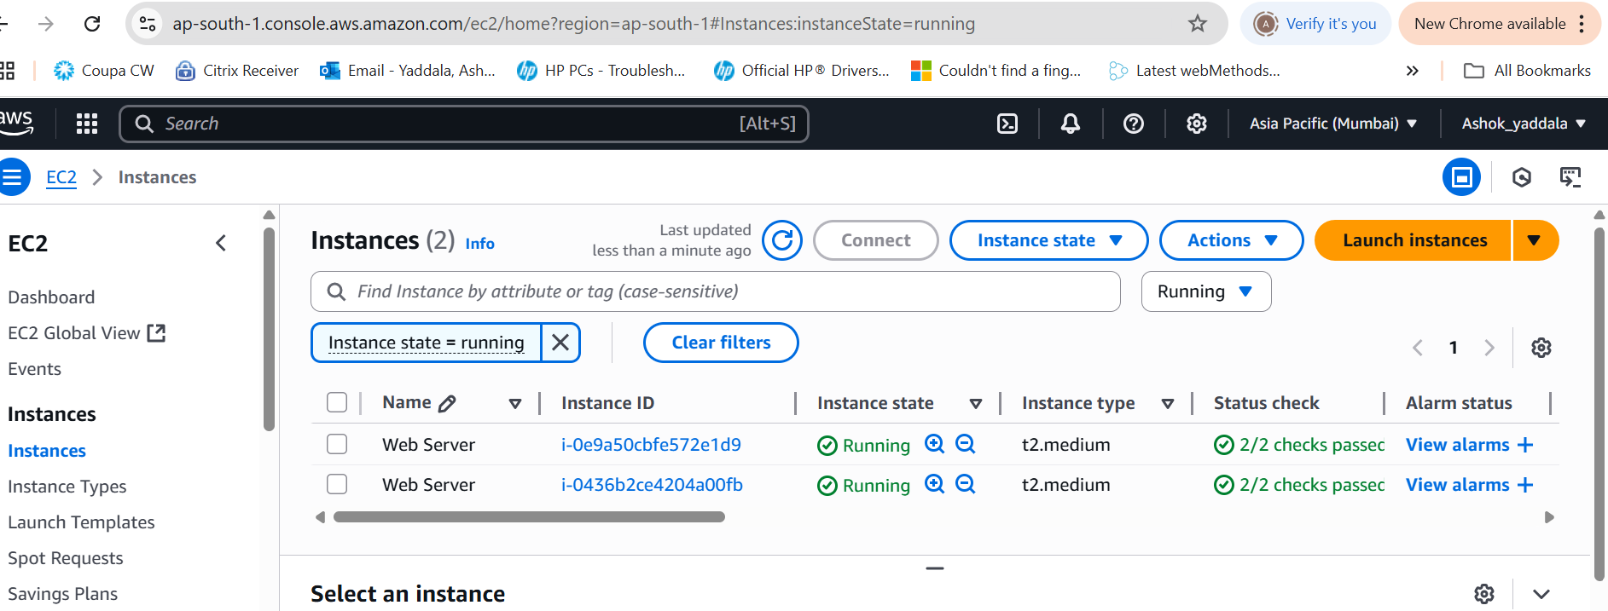

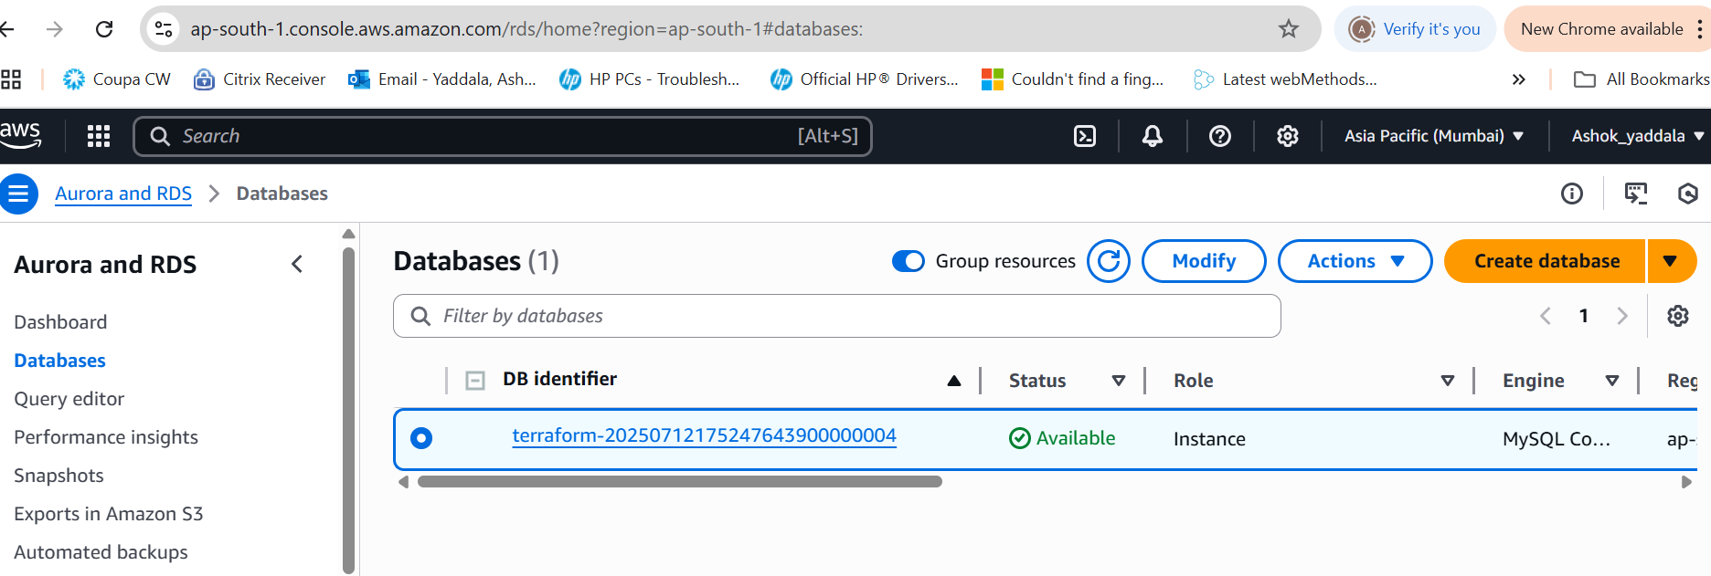

When we access the ec2 instance public ip address, we could see the below page.

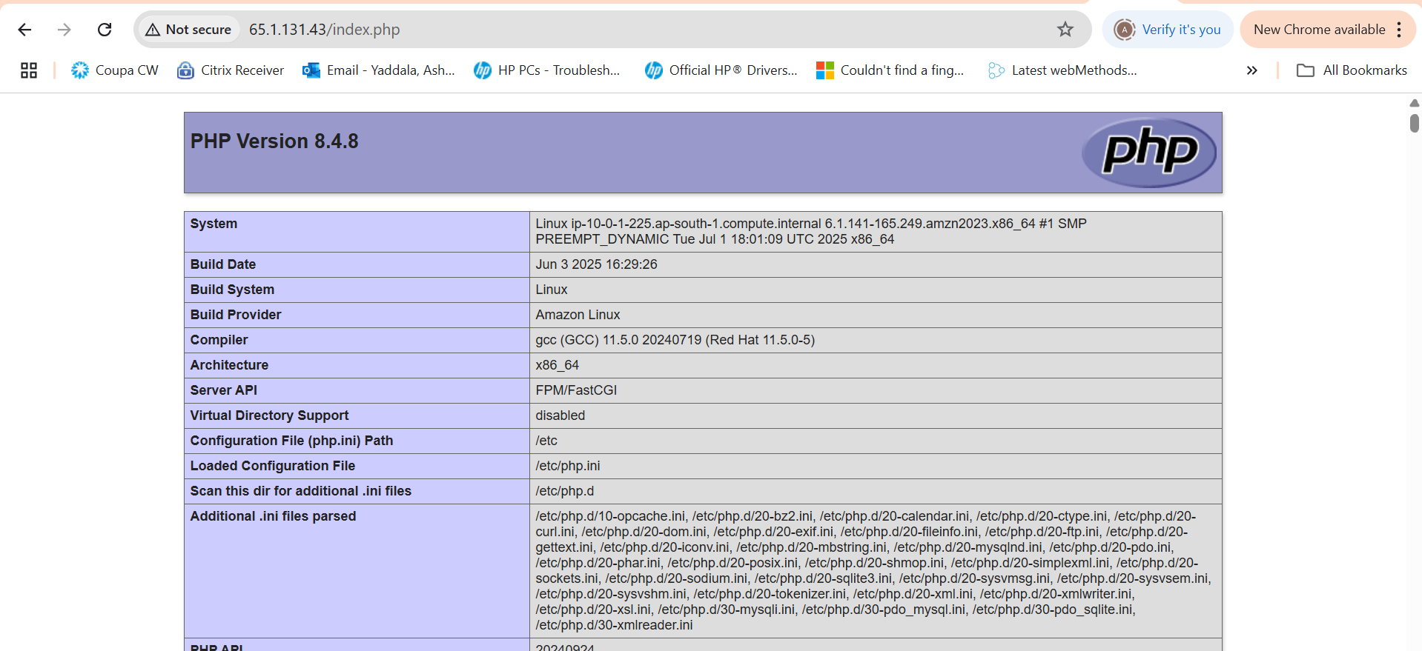

As part of this implementation, also implemented github actions pipeline. In the pipeline I’ve implemented one of the best practice using terraform. i.e. terraform-docs is used to **automate and standardize documentation** for your Terraform code. It saves time, improves readability, and ensures up-to-date module documentation.

